* Using axios as http client in vue

>> promise based library

>> 1. Npm I axios

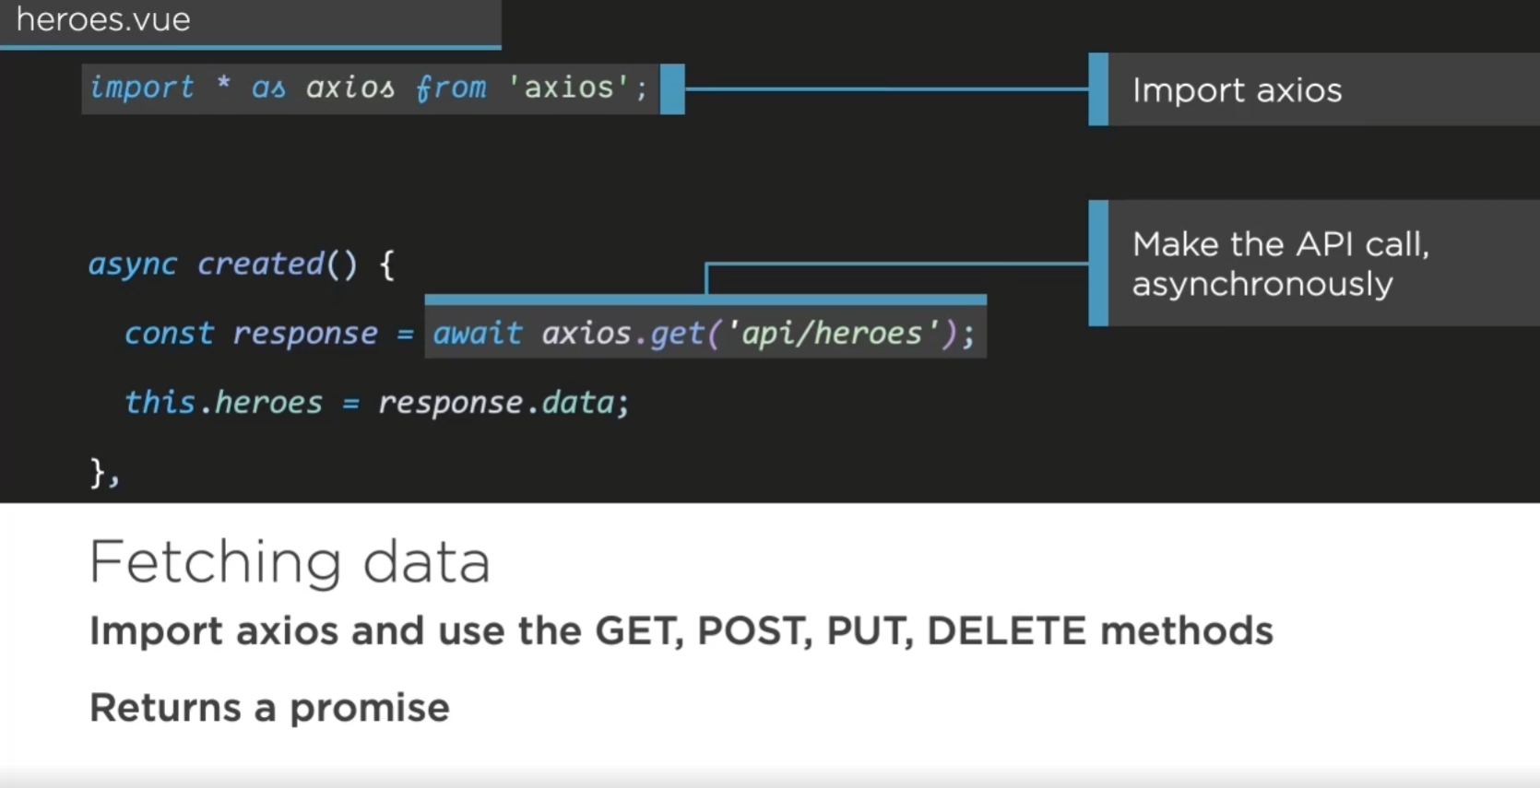

>> beside await (async), can also use .then syntax

\*\*\* 從資料夾中import複數個compenent



Demo part 1 >> data.js

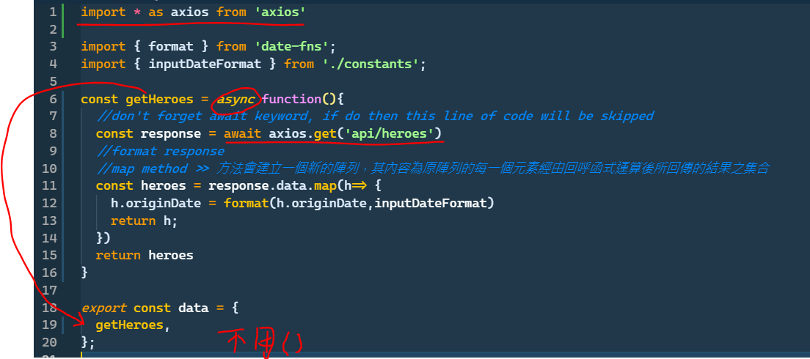

Demo part 2 >> main component

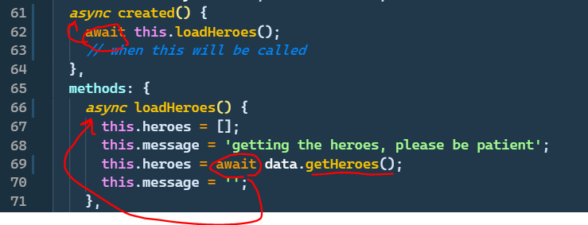

所有接觸到的上層的function都須要等他

>> 感覺還是用.then 比藥方便

>> ps: 這邊沒有await的話回傳型別是 promise

* Configure api path

1. 可以做到正式板根開發版api 分流: >> 把api參數寫在vue特有的.env檔



>> 長這樣





>> set to your api url

步驟:

1. 去.env (參數檔) 輸入參數
2. 建一個config.js去讀.env檔然後export出去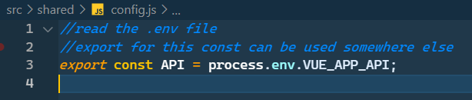
3. 去到index.js (export檔集散地) 然後把每個物件檔每個 .js的東西再export出去給

component用

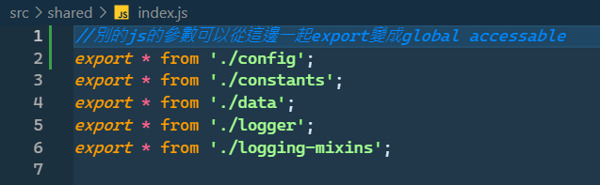

1. 回到component把api抓進來

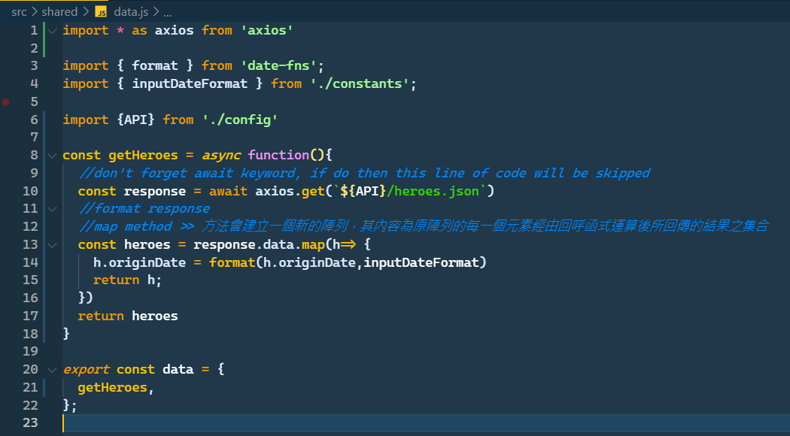



* Parse response and add error handling

1. Put code inside try catch block

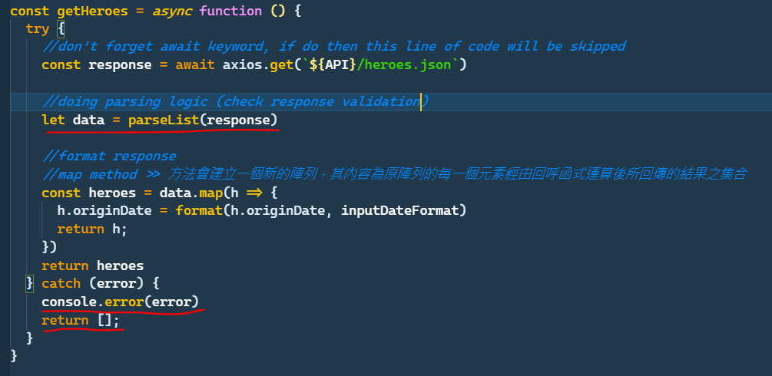

>> console.error can show error message

>> remember still have to return an empty arr for app to not break down

1. Create a validation function (elementary version)

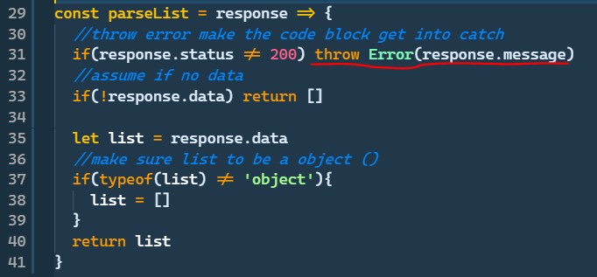

Recap

\*\*單字: interrogate : 審問

Ex: we can’t assume the data to sent back expectedly, we have to interrogate the data response.

